1. **When you want to share your code then Github or Self hosted git or Bitbucket comes into the picture.**
2. **Branching strategy in github?**

**Branch is nothing but a separation. Branching is useful when you have to add big or breaking changes in your code so for this you create a branch and your current working code or application does not affect.**

**I.Q:**

**Master/Main: This is a main branch**

**Feature: This branch created if we have to introduce new feature in application and we delete this branch and merge the code with main branch once all testing done on feature branch code.**

**Release: This branch created to deliver the application or new changes to the client. It is similar to main branch but main branch is active development branch since developers are actively working on main branch.**

**Hot Fix: This branch is created if your client is facing critical issue on their production app & you have to fix it & release that code very quickly to main and release branch.**

1. **I.Q: How to create or initialize the git repository?**

**#git init**

1. **#git push**

**To push your code to github**

1. **I.Q. What is a git workflow that you are using in your organization?**

**#git add && git commit -m “message” && git push**

1. **Git push command not working?**

**Possibly you have not configured remote repository. Remote repo means github, gitlab etc.**

1. **How to add remote repo on your local git server?**

**#git remote add -f swapniladivarekar** [**https://github.com/swapniladivarekar/swapmyrepo**](https://github.com/swapniladivarekar/swapmyrepo)

1. **#git remote -v**

**To check remote repo present on your local git server.**

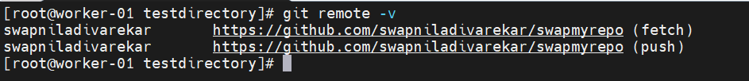

1. **I.Q. How to pull or clone the code from github?**

**# git clone** [**https://github.com/swapniladivarekar/myfirstrepo.git**](https://github.com/swapniladivarekar/myfirstrepo.git)

**You can download the code by using https or ssh option. For https you have to use github credentials, on other hand to ssh you need to add your public key on github portal.**

**https:**

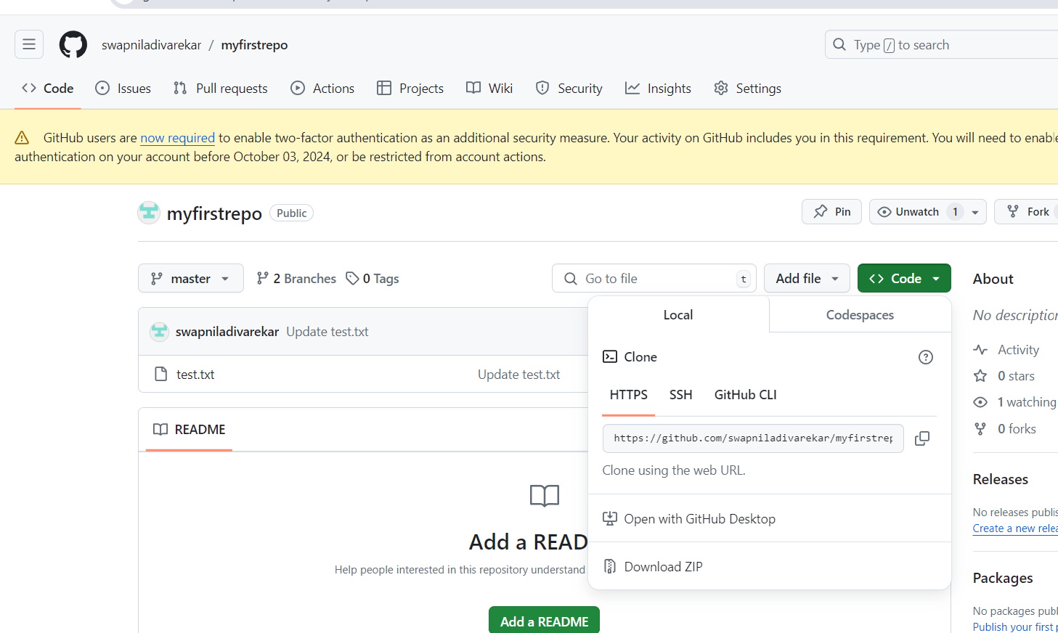

**Ssh:**



1. **I.Q. Difference between clone and fork?**

**Fork is used to create copy of repo whereas clone is used to download the repo.**

1. **How to create new branch in your main branch?**

**See basically this requirement comes when you have a working app or new application is built successfully. However, need big change in current app and do not want to affect the working code. In this case we create new branch under main branch.**

**By using branching technique, you can isolate or separate the development activity.**

**# git checkout -b newfunct**

**Git checkout command used to switch between branches.**

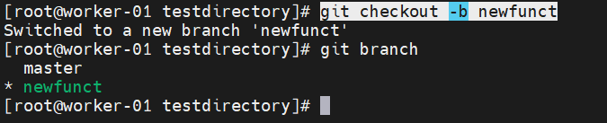

**Once you created new branch you can switch between master/main branch by using below command.**

**# git checkout master**

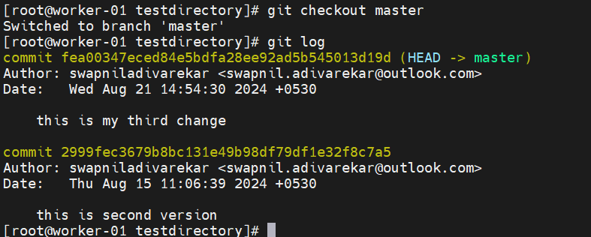

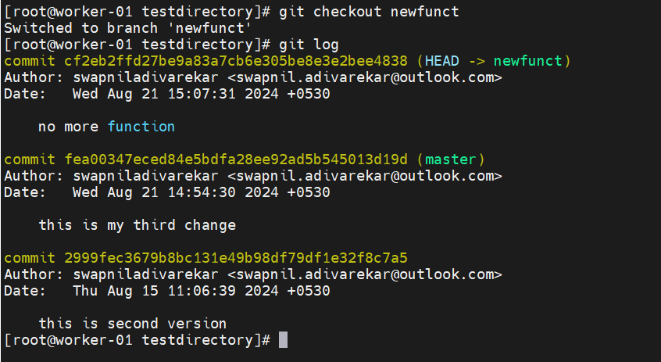

**Note: You can use below command to check commits of any branches instead of long process by switching branch first and then check commits by using git log command. You can run this command anywhere irrespective of branches.**

**# git log master**

**# git log newfunct**

